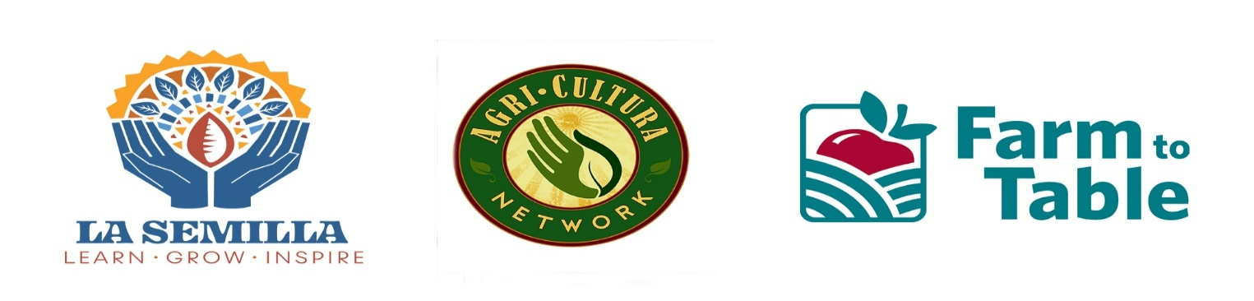
January 12, 2021

Re: Requesting Your Support for and expansion of the NM Grown Fruits and Vegetables for School, Senior and Early Childhood Meal Programs; Healthy Food Financing Initiative; Soil Health and Conservation Programs; and Agriculture Education Programs

Dear Honorable Senators and Representatives:

On behalf of the New Mexico Food and Agriculture Policy Council, Farm to Table, NM Farmers’ Marketing Association, La Semilla Food Center, Agri-Cultura Network, Center for Health Innovations and partner organizations, we are requesting legislative support for the following programs in the Legislative Budget:

NM Grown for School Meals:
(administered by the NM Public Education Nutrition and Wellness Department): Retain $400,000 in recurring funds to continue expansion for the program. The Legislative incentive is helping school districts learn how to purchase local produce and build it into their budgets. In 2019-20 schools purchased $1.15+ million.

NM Grown for Early Childhood Food & Nutrition Programs:
(administered by Early Childhood Department): $100,000 for Early Childhood food and nutrition programs to be able to purchase NM grown fruits and vegetables for their meal programs such as summer meal programs and the Child and Adult Care Food Program. Legislative Sponsor: Representatives Gail Armstrong and Rebecca Dow. Endorsed by the Legislative Education Study Committee

Purchase NM Grown Fruits and Vegetables for a Senior Citizen Meals Program
(administered by Aging and Long-Term Service Department): $250,000 for city, county, tribal, and non-profit administered NM senior centers to be able to purchase NM grown fruits and vegetables for their meal programs. New in 2019, this program needs time to get off the ground like the PED initiative that is highly successful. This would serve seniors across the state and create a new economic market for farmers. Legislative Sponsors: Senator Liz Stefanics and Representative Gale Armstrong. Endorsed by the Health and Human Service Interim Committee

We request funding for the New Mexico Food and Agriculture Education Grant Program (“NM Food and Ag Education Grant”). This program was established in the NM Department of Agriculture in 2019 with legislative funding and is supported by many schools, organizations, and youth agriculture related programs. The Education Grant Program would provide funding to schools for experiential and entrepreneurial learning opportunities in food and agriculture. These programs would broaden students’ professional horizons, reinforce multiple state-required subject areas, and give valuable life lessons on nutrition and health. The grant program has three areas of emphasis for schools to choose form: Agricultural Education, School Gardens/Outdoor Classrooms, and Food Education. It would further pair up with the expand the New Mexico Grown Program for School Meals.
These programs would broaden students’ professional horizons, reinforce multiple state-required subject areas, and give valuable life lessons on nutrition and health. The grant program has three areas of emphasis for schools to choose form: Agricultural Education, School Gardens/Outdoor Classrooms, and Food Education. It would further pair up with the expand the New Mexico Grown Program for School Meals.

Healthy Food Financing Initiative (HFFI):
(administered by Economic Development Department): The HFFI is an effective, viable, and economically sustainable solution to bring locally grown food and jobs into underserved communities without sufficient access to affordable, nutritious foods. The fund is a combination of public and private dollars that can achieve multiple goals: reducing health disparities, improving the health of families and children, creating quality jobs, and stimulating long-term local economic development in low-income communities. A $200,000 legislative investment in the HFFI can leverage $2 million in federal funds annually. Legislative Sponsor: Representative Angelica Rubio

Healthy Soil Program:
(Administered by the NM Department of Agriculture) Maintain $227,000 in recurring funds in the NM Department of Agriculture budget to incentivize farming and ranching systems that improve the health, yield and profitability of the soils of the state. Additionally, support the Voluntary Income Tax Designation for the NM Healthy Soil Program, sponsored by Representative Christine Chandler. This bill would enable NM residents with tax refunds to contribute to the Healthy Soil Program. Support for this program will benefit farmers and ranchers, the environment, public health and New Mexico’s emerging regenerative food economy. Providing creative funding mechanisms during a time of limited state resources is crucial. Funds support project grants for farmers and ranchers, program administration, education and outreach. Demand for the Healthy Soil Program has been strong, far exceeding available state funding, which is being matched with federal funds from USDA NRCS.

Conservation Programs and Agriculture Education:
Continue support for soil and water conservation programs while maintain resources for farm and ranch education programs through the Cooperative Extension Service, Experimental Stations, and Agriculture Workforce Program.

NM Agriculture Workforce:
Provides eligible agricultural businesses up to 50 percent of the costs to employ an intern, including wages, fixed expenses, and other costs. The agriculture business must provide an intern with at least 130 hours of work experience over no more than 1 year. The intern may not be a current or former employee or relative of the business owner or operator. Seeking $100k in funding to be administered by NMDA. Sponsors: Representative Martin Zamora and Senator Pat Woods

These programs will: enhance children’s diets while promoting healthier lifestyles and increasing academic achievement; increase access to New Mexico-grown fruits and vegetables for early childhood, students K-12, and seniors; provide soil health training, conservation programs, and technical assistance to farmers and ranchers; develop an agricultural workforce; and, strengthen New Mexico’s farming economy and rural sectors by expanding market opportunities for farmers.

Please feel free to call us if you have any questions. I can be reached at 505-660-8403.

Thank you for your consideration.

Sincerely,

Pam Roy Krysten Aguilar Helga Garza
Executive Director Co-Executive Director Executive Director
Farm to Table La Semilla Food Center Agri-Cultura Network
Santa Fe Anthony, NM South Valley Albuquerque
pam@farmtotablenm.org krysten@lasemillafoodcenter.org helgagarciagarza@gmail.com 505-660-8403 575-639-0493 505-217-2461

Susan Wilger Denise Miller Isabelle Jenniches
Executive Director Executive Director Co-Founder
Center for Health Innovation NM Farmers’ Marketing Association Soil Health Working Group
Santa Fe Santa Fe Santa Fe
swilger@swchi.org dmiller@farmersmarketsnm.org imjenniches@gmail.com
575-313-4720 505-699-2064 505-231-8471

All are representative members of the NM Food & Agriculture Policy Council

